[Enter technology name]
Put supplier logo here
[Enter supplier name]
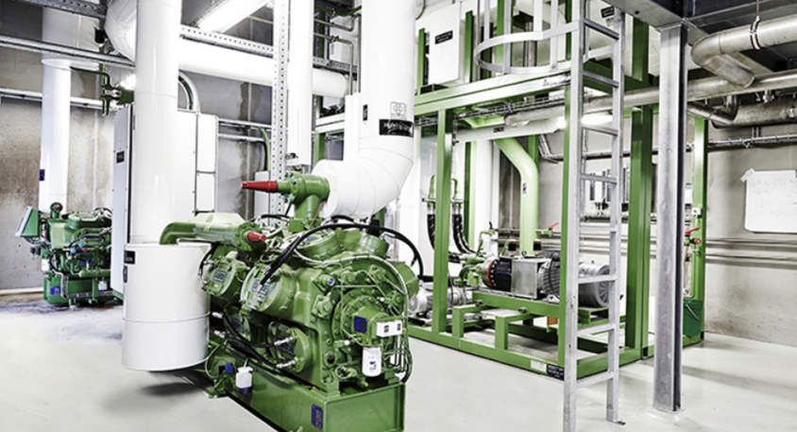
Figure 1: [Insert figure and figure text here.]

Summary of technology
[Please summarize the supplier technology in these columns to elaborate on the stated facts in the fact box. The summary must include information about:
- System layout and type, e.g. cascade system, open/closed, etc.
- Driving energy (electrically, heat, hybrid).
- Compressor technology.
- Standard unit, or application specific design?
- Performance: State COP in a given application and with sink and source temperatures (see table 1). Please note what type of COP that is referred to:
  - COPs were calculated (not for demonstration case)
  - COPs were measured on an operating plant in a laboratory/final installation
  - COPs were measured on an operating plant in a laboratory/final installation and are validated by …
- Development status: Laboratory demonstration, pilot plant, demonstration plant, units sold?
- What is suitable transport media on sink and source side? Any limitations?

The summary can preferable also include information on:
- Lubrication type and system (if available).
- Working fluid charge (kg/MW)
- Part load capabilities
- Market availability (Europe, North America, etc.)
- Safety concept (ATEX zones required?)
- Combination with storage?
- Info on heat exchangers or relevant sub-components
- Flexible operation and fast start-up and shut down times?
- Sound power level
- Electrical connection (Voltage, frequency…)
Guidelines for making description of supplier technology:
- Enter all information in square brackets, including the Fact Box.
- Technologies from Technology Readiness Level (TRL) 4-9 can be considered (not below 4).
- At least 1 figure must be included. A second figure can also be included if needed.
- Description must in total be able to fit on two pages.
- If information requested in fact box is not available, please write “-“.
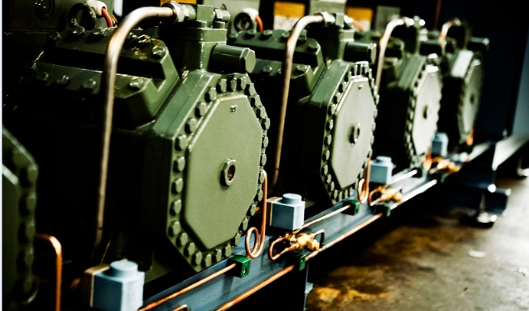
Figure 2: [Insert figure and figure text here.]
Table 1: Performance.
T_{source,in}  (T_{sat}*) | T_{source,out}  (T_{sat}*) | T_{sink,in}  (T_{sat}*) | T_{sink,out}  (T_{sat}*) | COP_{heating}**
[°C] | [°C] | [°C] | [°C] | [-]
…
…
* For steam, specify also the saturation temperature or pressure
** Specify: measured or calculated

[Summary stops here before project example section.]
Project example
Describe one specific application example and give the main figures for the application. This may include:
- Description of an application and the integration into the process.
- Main thermodynamic performance indicators
- End-user review/feedback.
- Main economic performance indicators.
- Possibilities for adjustments and extensions of the technology.
- Planned installation date.
[Project example stops here before contact info.]

FACTS ABOUT THE TECHNOLOGY
Heat supply capacity: [E.g. 1 MW or 1 MW to 5 MW; specify if single or multiple units]
Supply Temperature, max: [Indicate maximum supply temperatures in °C]
Temperature lift, max: [Indicate maximum temperature lift in K]
Working fluid: [E.g. CO₂, R1234ze(E), water,]
Heat carrier: [State which form is the heat supplied, i.e. steam, liquid, air]
Compressor technology: [piston, screw, turbo, rotary vane, …]
Specific investment cost for installed system without integration: [Estimate the on-site equipment cost, without expenses for process integration, consultancy and others. Please use the unit €/kW (thermal capacity). A prince range can be used if necessary.]
TRL level: [Based on Horizon 2020; from TRL 4 (Technology validated in lab) to TRL 9 (Actual system proven in operation)]
Operational hours achieved: [How long has systems been operating, e.g. 10.000 hours]
Expected lifetime: [Please estimate expected lifetime for technology, e.g. 20 years.]
Size: [Weight and footprint in m²]

Contact information

[enter name and organization]

[enter email address]
[enter phone number]

