[Insert headline here]
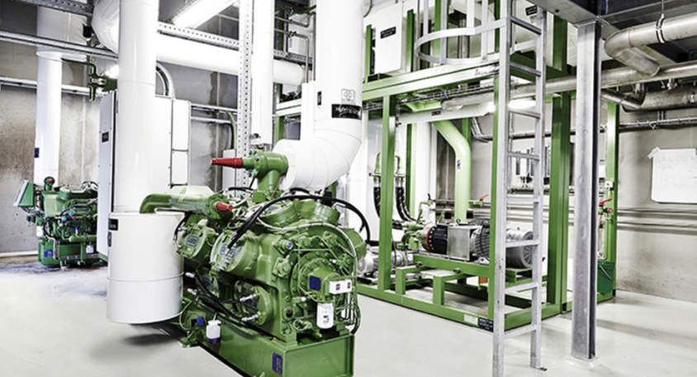
Figure 1: [Insert figure of the installation here and add a figure caption.]

Summary of demonstration case
[Please summarize the demonstration case in these columns to elaborate on the facts stated in the fact box. The summary must include information about:
- Information about the application, including process description, installation site, sector of installation, supplier, ...
- Information about the HP system, including layout of the HP cycle (e.g. cascade, single stage, transcritical, …).

The summary can preferable also include information on:
- Background for project.
- Description of process integration efforts (retrofit, new system?
- Does it also provide cooling services?
- Combined with any storage (electric of thermal)?
- Other relevant information…

“[Enter a quote here. E.g. from end-user, consultant, supplier, project manager. Quote should preferable be located in this position.]”
Summary is continued here under quote…

Guidelines for making description of demonstration case:
- Fill in all information in square brackets [], including the fact box on the right.
- It is a requirement that there has been made an definitive investment decision on the demo case.
- Two figures must be included:
  - One figure from the installation site.
  - Another figure showing the integration of the heat pump.
- Description must not be longer than these two pages.
- If information requested in fact box is not available, please write “-“.
Summary stops here before results section.]
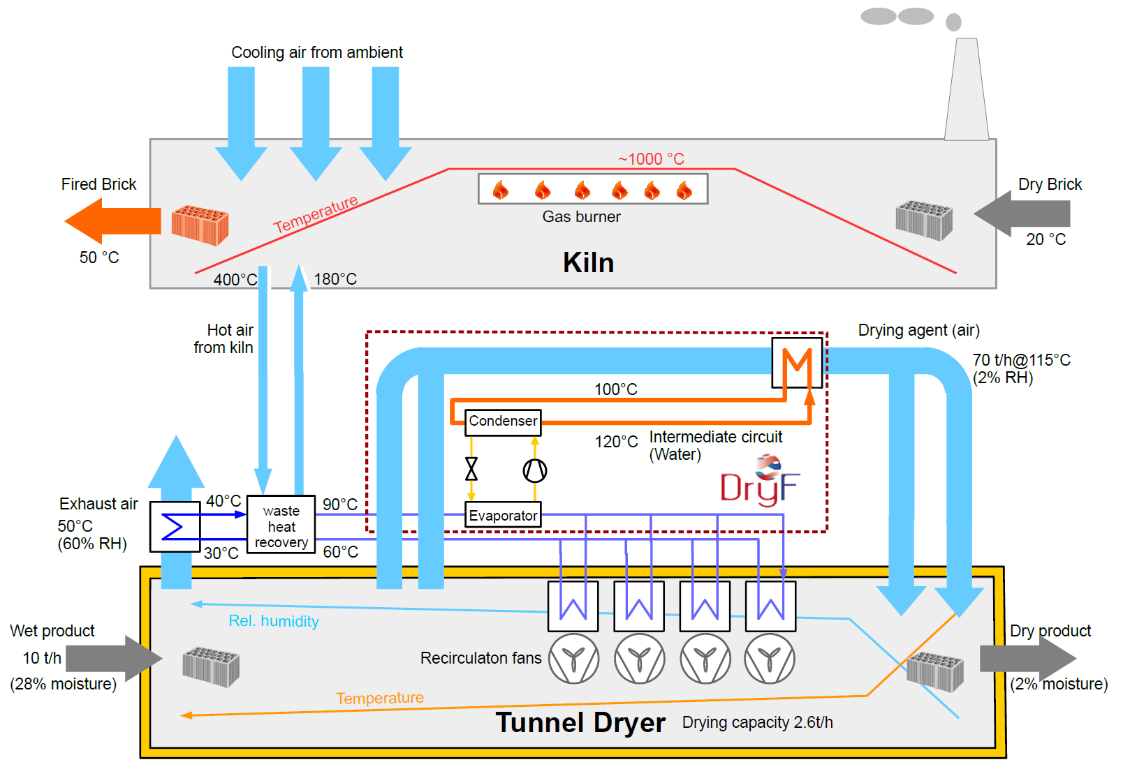
Figure 2: [Insert figure of the integration here and add a figure caption (reference: Wilk et al, AIT, DryF project, IEA Conference 2021).]

Operating experiences
Describe the main figures and experiences from operating the plant. This may include figures such as the main performance parameters, monetary savings and reduced environmental impact. Also elaborate on secondary effects, such as reduced cooling loads, no exhaust gases, and similar.

Special learnings
Here it should be mentioned, if there were special learnings resulting from the demonstration case, the integration process or the technology. In case you do not find any special learnings, feel free to delete this section.

FACTS ABOUT THE CASE
Installation year: [E.g. 2020]
Operating hours: [E.g. over 5000 hours/a]
Working fluid used: [E.g. CO₂, HFO, water]
Compressor technology: [piston, screw, turbo, rotary vane, …]
System manufacturer: [company name]
Sector: [E.g. chemicals, pulp & paper…]
Performance in design point:
- Heat source: [E.g. 70 °C 50 °C, air, water, thermal oil …]
- Heat sink: [E.g. 90 °C 130 °C, pressurized water, thermal oil air, steam, … Please indicate saturation temperature for steam]
- Heat supply capacity: [E.g. 1 MW]
- COP_{Heating}: [E.g. 3.1. Please also indicate where COP was measured (laboratory/final installation) and whether it has been validated.
Investment cost: [Estimation of installed system without cost for integration in €]
Savings: [Enter cost savings in the unit €/a]
Estimated annual CO₂ savings: [Use the unit t/a]
Link to webpage or report:
[enter link 1 here
enter link 2 here(if needed)]

Contact information

[enter name and organization]

[enter email address]
[enter phone number]

[Multiple contacts can be stated if necessary]

